TUSC Days of the Week-UNIVERSEDAY-MILKYWAYDAY-SOLARSYSTEMDAY-SUNDAY-MOONDAY-EARTHDAY-HUMANITYDAY
THE UNIVERSE STORY CALENDAR.org 2023ce
The Universe Story Calendar’s 12 months of the year
Flaring Forth—13.8byp...Galaxies—13.5 byp...Supernovas---12.8byp...The Sun---4.6byp...Living Earth—4.4byp…Eukaryote Cells---2.5byp... Plants&Animals---541myp...Human Emergence---7myp...Neolithic Villages---10,000bce…Classical Civilizations---3500bce...NationScience---1543ce...Ecozoic Era---1950ce
Classical Civilizations/October month-2022ce
“For whatever causes, there was a change at the end of the fourth millennium BCE from the dominant female deities to a dominance of male deities. The rise of technologies is also associated with the rise of men to dominant roles in society.” The Universe Story page 183 Classical Civilizations chapter
Year of the Individual Human Being- As 2022ce comes to a close, each human is called to be a learner and teacher of issues like world poverty, overcrowded world cities, and population.
OVERSHOOT-”The more potent human technology became, the more man turned into a colossus. Each human colossus required more resources and more space than each pre-colossus.” pg. 155 Overshoot. William Catton, Jr. 1980ce. Drawdown.org Solution #46 Low-Flow Filters(Home)
The Universe Story- The Classical Civilizations entered the Human Story around 3500bce with the increase in population and the need of various resources which cities provided. Chronic warfare, the major faiths and religions along with nation building were happening up to the 1500’s of our Common Era (ce).
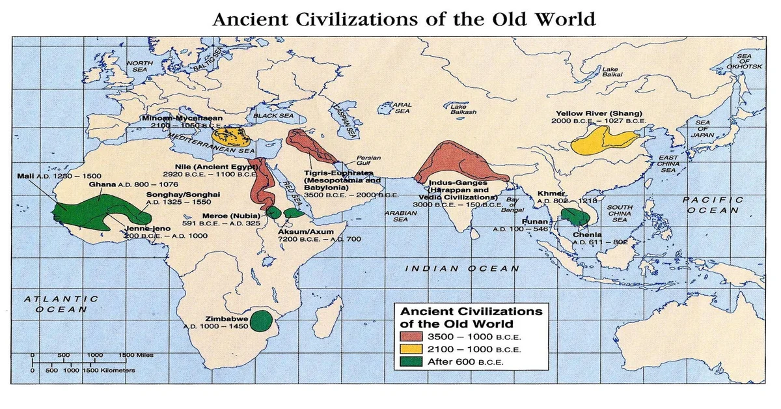
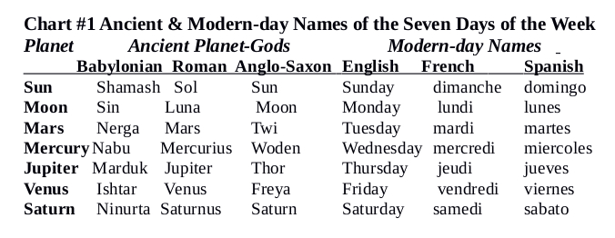
Above: From David Duncan’s book “Calendar” on page 45 shows various cultures and their calendars. Right: Classical Civilizations from 3500bce to past 600ce. Image Credit: memoriapress.com

NationScience/November month-2022ce
“Membership in the nation community easily becomes more significant than membership in a religious or cultural tradition. The nation-state has indeed become the sacred community.” The Universe Story page 213 Rise of Nations
“New technologies were emerging, new instruments of navigation, new ways of plotting the seas and continents, new instruments of warfare, new energy sources, new methods of production and commercial distribution.”
The Universe Story page 225 The Modern Revelation chapter
Year of the Individual Human Being- “New technologies…” of all kinds have been emerging these past 500 years with no real resource limits set. Each human being alive today needs to know this fact.
OVERSHOOT-The last three chapters of Catton’s book Overshoot are “Backing into the Future”, “Turning Around”, and “Facing the Future Wisely.” Who is? Drawdown Solution #47 Bio-plastics
The Universe Story- This month sees two chapters coming together from TUS book that have the same time periods, 1543-1950ce, beginning with Copernicus’ De Revolutionibus book that told the fact that the Earth revolves around the Sun, not the other way around. Nations had the other kind of “Revolution” going on as the numbers of countries grew to 193 (in the United Nations) by 2022ce.
Chart #13 below shows the paradigm shift that is happening at this time in our journey as a Human Species, at this time of Great Promise and Great Peril, when our new World Calendar comes forth!
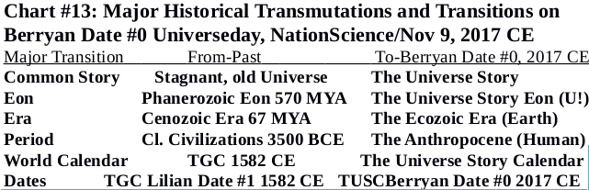
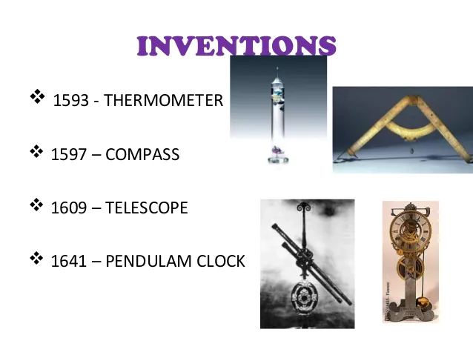
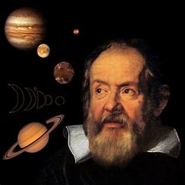

Above: Galileo Galilei and his inventions during our NationScience time period of 1543-1950ce. He is seen as one of our greatest scientists. He led the way to our nations of today astronomy, technology, and scientific facts and methods over religious beliefs. His discovery of Jupiter’s four moons with his nine inch telescope paved the way for confirmation of Nicholas Copernicus’ theory of a helio/sun-centered Universe at that time. Image Credit: Owlcation (Galileo and planets); Slideshare (Inventions)
THE UNIVERSE STORY CALENDAR-NationScience/Nov.-2022ce
TUSC>Sunday  TGC>Sunday | Moonday  Monday | Earthday  Tuesday | Humanityday  Wednesday | Universeday  Thursday | MilkyWayday  Friday | SolarSystemday  Saturday
NationScience Month covers 1543-1950ce  www.TheUniverseStoryCalendar.org |  | 1  Sunrise/set: 6:00am5:13pm  First Qtr: 9:38am  Moonrise/set: 12:54p11:53p Riyadh, Saudi Arabia  Earthday Weekly #260 | 2 International Day to End Impunity for Crimes against Journalists-UN | 3 | 4 | 5 World Tsunami Awareness Day-UN
6 UN-Inter. Week of Science & Peace-9-15  International Day for Preventing the Exploitation of Envir. In War/Armed-UN | 7 | 8  Moonset/rise: 5:49am5:10p  Sunrise/set: 6:04am5:09pm  Full Moon: 2:03pm  Last day of The Gregorian Calendar of 1582-2017ce on 11/8/17ce  Earthday Weekly #261 | 9 1st Universe Day International!-TUSCI  5th Anniversary of The Universe Story Calendar 2017-21CE  30th Anniversary of The Universe Story! | 10 World Science Day for Peace and Development-UN  Thomas Berry’s 108th Anniversary of Birth (the 9th) | 11  Berryan Date #1828 | 12 UN-Inter. Week of Science & Peace-9-15  **FLARING FORTH** CELEBRATION!  30TH Anniversary of The Universe Story!!  Time and Place TBA
13 | 14 World Diabetes Day-UN | 15  Earthday Weekly #262 | 16  Sunrise/set: 6:10am5:06pm  Moonset/rise: 12:33p11:45p  Last Qtr: 4:28pm  International Day of Tolerance-UN | 17 World Philosophy Day-UN | 18 | 19 World Day of Remembrance Road Traffic Victims-UN-on the 20th
20 World Children’s Day-UN | 21 World Television Day-UN | 22  Earthday Weekly #263 | 23 | 24  New Moon: 1:58am  Sunrise/set: 6:15am5:04pm  Moonrise/set: 6:35am5:27p | 25 International Day for Elimination of Violence against Women-UN | 26
27 Liturgical New Year: Western Christians | 28 | 29 International Day of Solidarity with the Palestinian People-UN  Earthday Weekly #264 | 30  Sunrise/set: 6:20am5:04pm  Moonrise/set: 12:19p11:53p  First Qtr: 5:38pm  All Victims of Chemical Warfare-UN | KEY for Terms  by=Billion Years  my=Million Years  byp=Billion Years Past  myp=Million Years Past  AofT=As of Today  U!=Universe  UN=United Nations | KEY for Terms  TUSC=The Universe Story Calendar  TUS=The Universe Story  TGC=The Gregorian Calendar  ce=Common Era  bce=Before Common Era | Sun and Moon Times for Riyadh, Saudi Arabia

The Ecozoic Era/December month-2022ce
“We few billion humans alive today represent through no democratic choice whatsoever the millions of generations of our ancestors and millions more generations of our potential descendants, with all their hopes and dreams and creations. We randomly-alive-today people actually have the power to end this evolutionary miracle...”
The New Universe and the Human Future (Abrams-Primack) page 100
Year of the Individual Human Being- This final month of the fifth full year of The Universe Story Calendar brings reality to The Ecozoic Era (TEE). Unlike the old December this new month wakes us to this fact: “We randomly-alive-today people actually have the power to end this evolutionary miracle...”
OVERSHOOT-This Ecozoic Era calls each individual human being to begin “Facing the Future Wisely.” Through deep acceptance and pro-generative resolutions to our ecological choices over our past 300 years of industrialism, we can wisely begin to adapt. Drawdown Solution #48 Small Hydropower
The Universe Story- This month brings forth our new Eon beginning in 1950ce; The Universe Story Eon (TUSE). TUSE gives us our comprehensive context going forward to understand and celebrate. In addition, The Anthropocene Period (TAP), is welcomed as our Human species becomes consciously self-aware.
Ecozoic Solstice is celebrated World-wide this month. The Ecozoic Season lasts until Supernovas Equinox.
Table 2: Analysis of Several Modes of Adaptation to Ecologically Inexorable [Impossible to stop] Change
NEW ECOLOGICAL UNDERSTANDINGS in “Overshoot” by William Catton, Jr. pg 71.
Adaptations (by some) Circumstance: Consequence: Names
Major Institutional = Circumstance: Age of + Consequence: Change to forms that = Realism change essential Exuberance is Over accord with finite limits
Faith in Technology & = Circumstance accepted + Consequence disregarded = Cargoism Progress to save us
Family planning, recycling, = Circumstance disregarded + Consequence partially accepted = Cosmeticism anti-pollution will save us
No History significance = Circumstance disregarded + Consequence disregarded = Cynicism Limitlessness Valid = Circumstance denied + Consequence denied = Ostrichism
ABOVE: The essential move from “Limitlessness of resources/Ostrichism” to “Deep adaptation to Human Overshoot/Realism.” Where/who are you?
THE UNIVERSE STORY CALENDAR Ecozoic Era/December-2022ce
TUSC>Sunday  TGC>Sunday | Moonday  Monday | Earthday  Tuesday | Humanityday  Wednesday | Universeday  Thursday | MilkyWayday  Friday | SolarSystemday  Saturday
KEY for Terms  TUSC=The Universe Story Calendar  TUS=The Universe Story  TGC=The Gregorian Calendar  ce=Common Era  bce=Before Common Era  EST=Eastern Standard Time-USA | KEY for Terms  by=Billion Years  my=Million Years  byp=Billion Years Past  myp=Million Years Past  AofT=As of Today  U!=Universe  UTC=Universal Time Coordination-UK |  | Sun and Moon Times for Thinadhoo, Maldives | 1 World AIDS Day-UN | 2 International Day for the Abolition of Slavery-UN | 3 International Day of Persons with Disabilities-UN
4 | 5 World Soil Day-UN International Volunteer Day-UN | 6  Earthday Weekly #265 | 7 | 8  Moonset/rise: 5:53am6:17p  Sunrise/set: 5:57am6:02pm  Full Moon: 9:09am  Thinadhoo, Maldives | 9 International Anti-Corruption Day-UN | 10 Human Rights Day-UN
11 International Mountain Day-UN | 12 International Universal Health Coverage Day-UN | 13  Earthday Weekly #266 | 14 | 15 | 16  Sunrise/set: 6:01am6:06p  Moonset/rise: 12:10pNone  Last Qtr: 1:57pm  Berryan Date #1863 | 17
18 International Migrants Day-UN | 19 | 20 International Human Solidarity Day-UN  Earthday Weekly #267 | 21 Ecozoic/Dec  Solstice & Season  World/Earth-wide  21:48 UTC  4:48pm EST  Yule/New Year-Witta | 22  The Ecozoic Season begins. It ends on Supernovas/March Equinox. | 23  Moonrise/set: 5:44am6:14p  Sunrise/set: 6:04am6:10pm  New Moon: 3:18pm | 24
25 | 26 | 27 International Day of Epidemic Prep.-UN  Earthday Weekly #268 | 28 | 29 2023ce:  Year of the  Great Turning @round!  TUSCI | 30  Sunrise/set: 6:08am6:13p  First Qtr: 6:22am  Moonrise/set: 12:21pNone | 31 New Year’s Eve-The Universe Story Calendar

Primordial Flaring Forth/January month-New Year 2023ce!
“13.8 Billion Years has passed since our glorious beginning. When our Story of Unity, starting unfolding our Universe. Twinkle, twinkle, came our Stars, Octillions in the two trillion Galaxies.” Thomas R Spiritbringer
Welcome to the beginning of the sixth full year of The Universe Story Calendar: 2023ce-The Year of the Great Turning @round! From this Flaring Forth month to the concluding Ecozoic Era month we will journey together as the Human Family with a sense of gratitude, reverence, and awe for this common New Story of how “all that is came to be.” This is the year for “Universe consciousness!”
OVERSHOOT- “Backing into the Future”, “Turning Around”, and “Facing the Future Wisely” are the last three chapters of the “Overshoot” book. Where are you? Drawdown(of CO²) Solution #49 Cars
The Universe Story- These first 31 days of 2023ce celebrate the Flaring Forth of our Universe covering the first one billion years of the New Story. From the Origin Seed of all the Physical-Material and Psychical-Spiritual Energy that would ever exist in the Universe to the birthing of the very first Galaxy is celebrated!
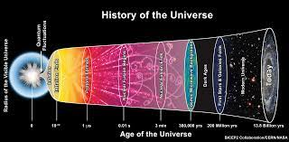
2023ce: International Year and Decade of: The Year of: *The Great Turning @round! (GT@)-TUSCI & *Millet-Cereal crops and grains for human food-United Nations (UN)
And Decade of: *The Family Farm-2019-28ce-UN & *Indigenous Languages 2022-31ce-UN
Above: The Primordial Flaring Forth/Big Bang of the Universe began after the energy of Quantum Fluctuation. Image Credit: Wikipedia Commons
THE UNIVERSE STORY CALENDAR-Flaring Forth/January-2023ce
TUSC>Sunday  TGC>Sunday |  |  | Moonday  Monday | Earthday  Tuesday | Humanityday  Wednesday | Universeday  Thursday | MilkyWayday  Friday | SolarSystemday  Saturday
1  New Year’s Day!  The Universe Story Calendar! |  |  | 2 | 3  Earthday Weekly #269 | 4 World Braille Day-UN | 5 | 6 | 7  Moonset: 5:15am  Sunrise: 5:41am  Full Moon: 9:09am  Sunset: 8:52pm  Moonrise: 9:33pm
8 |  |  | 9 | 10  Earthday Weekly #270 | 11 | 12 | 13 Berryan Date #1891 Berryan Date is the number of days since the start of TUSC in honor of Thomas Berry | 14  Orthodox Christian New Year
15  Moonrise: 12:25am  Sunrise: 5:50am  Last Qtr: 12:12pm  Moonset: 1:39pm  Sunset: 8:50pm |  |  | 16 | 17  Earthday Weekly #271 | 18 | 19 | 20 | 21
22  Moonrise: 5:41am  Sunrise: 5:59am  New Moon: 6:54am  Sunset: 8:45pm  Moonset: 9:31pm |  |  | 23 | 24 International Day of Education-UNESCO  Earthday Weekly #272 | 25 | 26 | 27 Int’l Holocaust Remembrance Day-UN | 28
29  Moonset: 12:08am  First Qtr: 1:20am  Sunrise: 6:08am  Moonrise: 2:34pm  Sunset: 8:39pm |  |  | 30 World Neglected Tropical Diseases Day-UN | 31  Earthday Weekly #273 | 2023ce  Year of the Great Turning @round! | Sun and Moon Times are for Hobart, Tasmania | Many faiths, nations, cultures and calendars celebrate Flaring Forth 1, 2023ce as New Year’s Day. | 2023ce!
 |  | Calendar format courtesy of 2017 Edwards Apps, Inc. www.SunriseSunset.com.

Galaxies/February month-2023ce
Hydrogen and helium “will tell us tremendously important things about the Milky Way, but unless we also reflect on the fact that the Milky Way in its later modes of being is capable of thinking and feeling and creating, we are failing to confront the galaxy as it is.” The Universe Story page 38 Galaxies chapter
Year of the Great Turning @round!-Each of us are the mode of being that is “capable of thinking and feeling and creating.” This whole year is dedicated to offering each of us humans the opportunity to “Turn Around” and seek out who we are, where we are going, how to get there, and why.
OVERSHOOT- As our galaxy is a generator and birther of stars and planets, we Homo sapiens creator have overshot our use of natural resources to make things and objects. Solution #50 Co-generation
The Universe Story- Galaxies month represents around two trillion galaxies that have come forth in the Universe beginning about 300 million years after the primordial Flaring Forth 13.8byp. As with MilkyWayday, Galaxies month deeply honors our barred spiral galaxy that has birthed the Sun, Earth, and us.
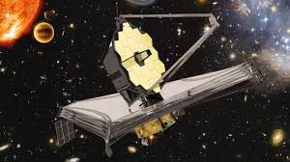
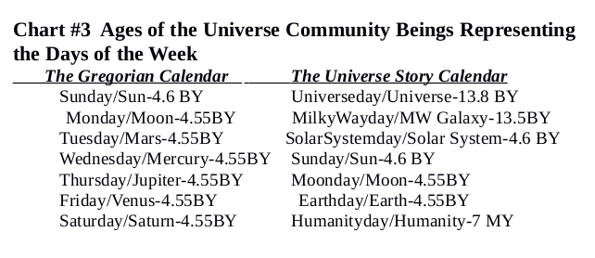
2023ce: Year of the Great Turning @round! and the James Webb Space Telescope! Our Milky Way Galaxy birthed our Sun, then Sun birthed Earth. Each individual human being was birthed here on Earth. Chart #3 above is taken from the book The Universe Story Calendar. Above: The James Webb Space Telescope (JWST) was launched on Ecozoic/Dec. 25, 2021ce. It is 100 times stronger than the Hubble Telescope. It is one million miles up in space at the LaGrange/L2 Point. Hubble was only 300 miles up! JWST is taking us back to the first galaxies some 13.5 billion years past! Check out NASA.gov for pics. Image Credit: esa.int
THE UNIVERSE STORY CALENDAR-Galaxies/February-2023ce
TUSC>Sunday  TGC>Sunday | Moonday  Monday | Earthday  Tuesday | Humanityday  Wednesday | Universeday  Thursday | MilkyWayday  Friday | SolarSystemday  Saturday
Galaxies began forming around  13.5byp |  | Earthday Weekly #274 | 1 World Interfaith Harmony Week-UN 1-7  Chinese New Year until the 15th | 2 World Wetlands Day-UN | 3  Berryan Date #1912 | 4 World Cancer Day-UN
5  Sunrise: 7:57am  Moonset: 8:13am  Full Moon: 5:30pm  Moonrise: 6:08pm  Sunset: 6:20pm | 6 International Day of Zero Tolerance to Female Genital Mutilation-UN | 7  Earthday Weekly #275 | 8 | 9 | 10 World Pulses/ Edible Legume Seeds-UN | 11 Evolution Weekend 10th to 12th -TUSCI  Darwin’s Birth 1809ce International Day of Women and Girls in Science-UN
12 | 13 World Radio Day-UN  Moonrise: 1:21am  Sunrise: 7:48am  Moonset: 11:34am  Last Qtr: 3:02pm  Sunset: 6:29pm | 14  Earthday Weekly #276 | 15 | 16 | 17 | 18
19 | 20 World Day for Social Justice-UN  New Moon: 6:07am  Sunrise: 7:40am  Moonrise: 8:09am  Sunset: 6:37pm  Moonset: 7:05pm | 21 International Mother Language Day-UN  Losar-Tibetan Buddhism New Year  Earthday Weekly #277 | 22 | 23 | 24 | 25
26 | 27  Moonset: 2:04am  First Qtr: 7:07am  Sunrise: 7:30am  Moonrise: 11:35am  Sunset: 6:44pm | 28  Earthday Weekly #278 | Sun and Moon times are for Horta, Ilha do Faial, Azores | KEY for Terms  by=Billion Years  my=Million Years  byp=Billion Years Past  myp=Million Years Past  AofT=As of Today  U!=Universe  UN=United Nations | KEY for Terms  TUSCI=The Universe Story Calendar Initiative  TUS=The Universe Story  TGC=The Gregorian Calendar  ce=Common era  bce=Before common era | 2023ce is not a Leap Year. 2024ce is!

Supernovas/March month-2023ce
“If there is any event in the Universe with the power to evoke a sense of the sublime, it is the Supernova explosion. It is spectacular in the present; it shapes the future; and it has been prepared for since the beginning of time.” The Universe Story page 49 Supernovas chapter
Year of the Great Turning @round!- As the Supernova “has been prepared for since the beginning of time” so have you and me. Each individual human being has been generated and birthed from Supernova star-stuff that can be traced back to the Primordial Flaring Forth 13.8byp. The Universe and Earth are two of the great generators and birthers of our Homo sapiens creator sub-species. With the aid of educational teaching tools like this calendar each individual human’s journey unfolds.

OVERSHOOT- Similar to human overshoot of non-renewable natural resources, supernovas had been unfathomable and inconceivable until late last century! #51 Perennial(Grasses-Woody Plants) Biomass
The Universe Story- Supernovas are certain giant stars that implode and explode, spewing out into the Universe the building block elements of carbon, nitrogen, oxygen and others, that will form new stars, planets, and moon satellites. The “super-luminous” Supernova ASASSN#15 was reported on June 15, 2015ce from Cerro Tololo, Chile with a brightness 570 billion, yes billion, times that of our Sun! These facts can help us see the destructive, generative, and expansive powers of our tremendous Universe and Supernovas.
Supernovas/March Equinox and Season in 2023ce Many humans on Earth experience about 12 hours of daytime and nighttime at Equinox. The new Earth-wide name of Supernovas Equinox brings unity. The new Supernovas Season moves through the Sun and Living Earth months ending at Eukaryotes/June Solstice. Chart #10 below is from TUS Calendar book pg. 102. Book pdf for download at www.theuniversestorycalendar.org
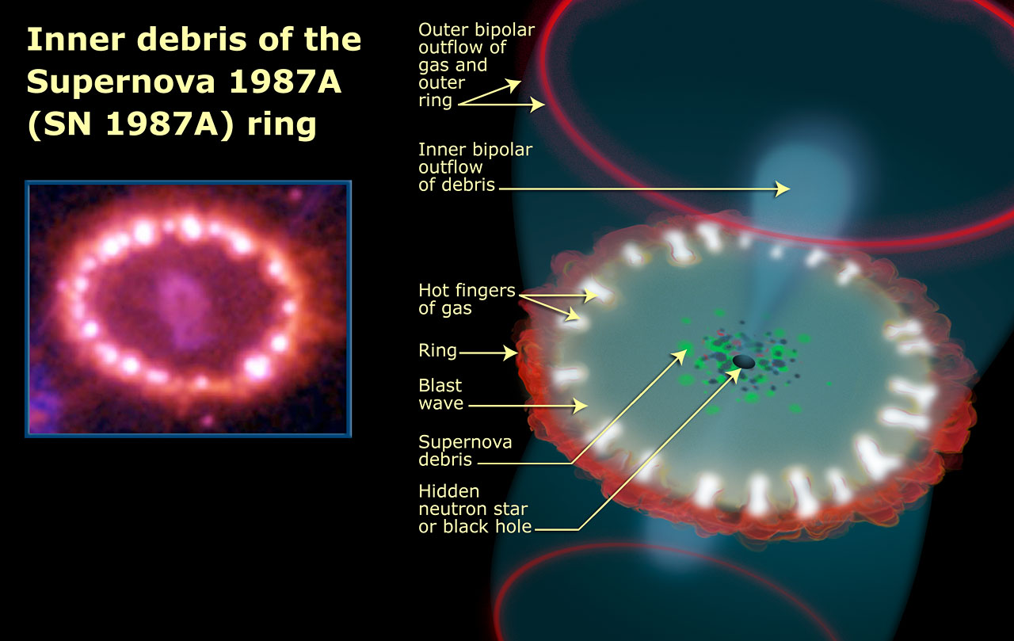
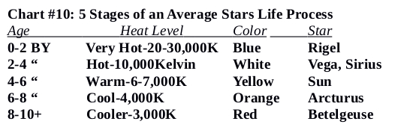
Far Right: The inner debris of Supernova 1987A. Supernovas help us Humans realize just how expansive our Universe is. Image Credit: HUBBLE
THE UNIVERSE STORY CALENDAR Supernovas/March-2023ce
TUSC>Sunday  TGC>Sunday | Moonday  Monday | Earthday  Tuesday | Humanityday  Wednesday | Universeday  Thursday | MilkyWayday  Friday | SolarSystemday  Saturday
Sun and Moon times are for South Pole | KEY for Terms  by=Billion Years  my=Million Years  byp=Billion Years Past  myp=Million Years Past  AofT=As of Today  U!=Universe  UN=United Nations |  | 1 Zero Discrimination Day-UN | 2 | 3 World Wildlife Day-UN  Losar-Tibetan Buddhism New Year | 4
5 | 6 | 7  Sun: up all day  Full Moon: 12:42pm  Moon: down all day  Earthday Weekly #279 | 8 International Women’s Day-UN | 9 | 10 Berryan Date #1947 | 11 International Fukushima Disaster Remembrance Day
12 | 13 | 14 Sikh New Year’s Day 554 Nanakshahi  Earthday Weekly #280 | 15 Sun: up all day  Moon: up all day  Last Qtr: 2:09am | 16 | 17 | 18
19 The Supernovas Season begins! It ends on Eukaryotes Solstice. | 20 Supernovas/ March Equinox Earthwide  21:24UTC/2:24amPST  Bahai New Year  1745be Naw-Ruz on 21st | 21 Week of Solidarity w/Peoples Struggling against Racism-UN  International Day of Nowruz-UN  New Moon: 5:24pm  Earthday Weekly #281 | 22 World Water Day-UN  International Day of Forests-UN (21st)  World Downs (21st) Syndrome Day-UN | 23 World Meteorological Day-UN | 24 World Tuberculosis Day-WHO | 25 International Day of Remembrance of Victims of Slavery-UN
26 | 27 | 28  Earthday Weekly #282 | 29 Sun: down all day  First Qtr: 2:34am  Moon: down all day | 30 | 31 | KEY for Terms  TUSC=The Universe Story Calendar  TUS=The Universe Story  TGC=The Gregorian Calendar  ce=Common Era  bce=Before Common Era

Sun/April month-2023ce
“And at least one of these, the Sun, managed to enter the deeper reaches of the Universe creativity, a realm where the complexity, self-manifestation, and reciprocity at the very heart of the Universe revealed themselves in a way transcending anything that had occurred for ten billion years-as an extravagant, magical and Living Earth burst into a new epoch of The Universe Story.” The Universe Story page 79 Sun chapter

Year of the Great Turning @round!- Our entire stellar system humans named “solar” is a system of planets, satellite moons, asteroids, etc. that were in some manner generated and birthed through our day star we named Sun. Universe gifted us with a medium yellow star unlike any other by far. Through the Sun, our garden planet named Earth, was born. Then Earth birthed the only plants and animals, including individual human beings, alive, as of today, in the Universe. Each member of our species alive in 2023ce is invited to this new story of how each human came to be.
OVERSHOOT- Facing the future wisely can happen for individual human beings through processes like Deep Adaptation. (ref. book by Bendell and Read 2021ce) Drawdown Solution #52 Coastal Wetlands
The Universe Story- Our day star Sun is one of up to 400 billion stars in our Milky Way galaxy. 1.3 million Earth’s would fit into our Solar System’s centerpiece. Sun’s gravity pulled bits and pieces of Supernova explosions to birth our “Garden planet of the Universe” and become our “Bringer of Energy” for the last 4.6 billion years! This month also brings us the Cosmogenetic Principles of Differentiation/Uniqueness, Subjectivity/Interiority, and Communion/Kinship. Cosmogenesis=Universe is ever-changing and dynamic.
Earthday Weekly & Earth Day Yearly in Sun/April 2023ce!
Each week on the former Tuesday is Earthday Weekly to celebrate our planet. 52 times a year! 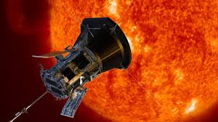Parker Solar Probe. Image Credit: NationalGeographic
Celebrate our day star Sun’s gift of the generation and birth of our planet Earth each Earthday Weekly!
THE UNIVERSE STORY CALENDAR Sun/April-2023ce
TUSC>Sunday  TGC>Sunday | Moonday  Monday | Earthday  Tuesday | Humanityday  Wednesday | Universeday  Thursday | MilkyWayday  Friday | SolarSystemday  Saturday
30 International Jazz Day-UN | The Sun is 4.6 billion years young! Sun is in mid-life Now! | KEY for Terms  by=Billion Years  my=Million Years  byp=Billion Years Past  myp=Million Years Past  AofT=As of Today  U!=Universe WHO=World Health Organization | KEY for Terms  TUSCI=The Universe Story Calendar Initiative  TUS=The Universe Story  TGC=The Gregorian Calendar  ce=common era  bce=before common era | Sun & Moon times are for George Town, Cayman Islands |  | 1
2 World Autism Awareness Day-UN | 3 | 4 International Mine Awareness Day-UN  Earthday Weekly #283 | 5 International Day of Conscience-UN  Moonset: 6:00am  Sunrise: 6:17am  Moonrise: 6:28pm  Sunset: 6:40pm  Full Moon: 11:36pm | 6 International Day of Sport for Peace and Development-UN | 7 Day of Victims of Rwanda Genocide-UN World Health Day-WHO  Berryan Date #1975 | 8
9 | 10 | 11  Earthday Weekly #284 | 12 International Day of Human Space Flight-UN | 13  Moonrise: 1:19am  Last Qtr: 4:13am  Sunrise: 6:10am  Moonset: 12:25pm  Sunset: 6:42pm | 14 | 15
16 | 17 | 18 Celebrating Berryan Date #2000! Days since the beginning of TUSCI on 11/9/17!  Earthday Weekly #285 | 19  Moonrise: 5:43am  Sunrise: 6:06am  Moonset: 6:30pm  Sunset: 6:44pm  New Moon: 11:14pm | 20 Universeday  The Universe Story Calendar’s  Earthday Celebration Week! Sun/Apr. 20-26 | 21 MilkyWayday | 22 SolarSystemday  53rd Anniversary!  Int’l EARTH DAY YEARLY-UN  1970-2023ce!
23 Sunday | 24 Moonday | 25 Earthday Weekly International #233  World Malaria Day-WHO  Earthday Weekly #286 | 26 Humanityday  International Chernobyl Disaster Remembrance Day-UN | 27  Moonset: 12:56am  Sunrise: 6:00am  Moonrise: 12:05pm  First Qtr: 4:21pm  Sunset: 6:46pm | 28  30th is above in the first row! | 29

Living Earth/May month-2023ce
“Sun and Earth awakened Earth’s life. The energy in the Solar System transformed atmosphere and ocean, swirled into young seething Earth and erupted as lightning that initiated the proto-cellular chemical reactions. Life was born in a lightning flash.” The Universe Story page 86 Living Earth chapter

Year of the Great Turning @round!- Every human being in 2023ce would benefit from knowing the five eons of Earth’s story. Hadean 4.567-4.0byp; Archean 4.0-2.5byp; Proterozoic 2.5byp-541myp; Phanerozoic 541myp-1950ce; The Universe Story 1950ce-Future. Living Earth’s story is our story!
OVERSHOOT- Homo sapiens creator were birthed within the Homo genus as one of the Earth Community of Beings subspecies, part of the living Earth. Drawdown.org #53 Rice Intensification
The Universe Story- After the Universe “Flared Forth” with Galaxies, Stars and Supernovas, that then evolved into Stellar Systems with revolving planets. Earth is the one planet we know of As of Today that is “Living.” During the Archean Eon of 4.0-2.5byp, Living Earth month educates us on those building block cells of life after 600 million years of planet and asteroid bombardment of our molten planet.
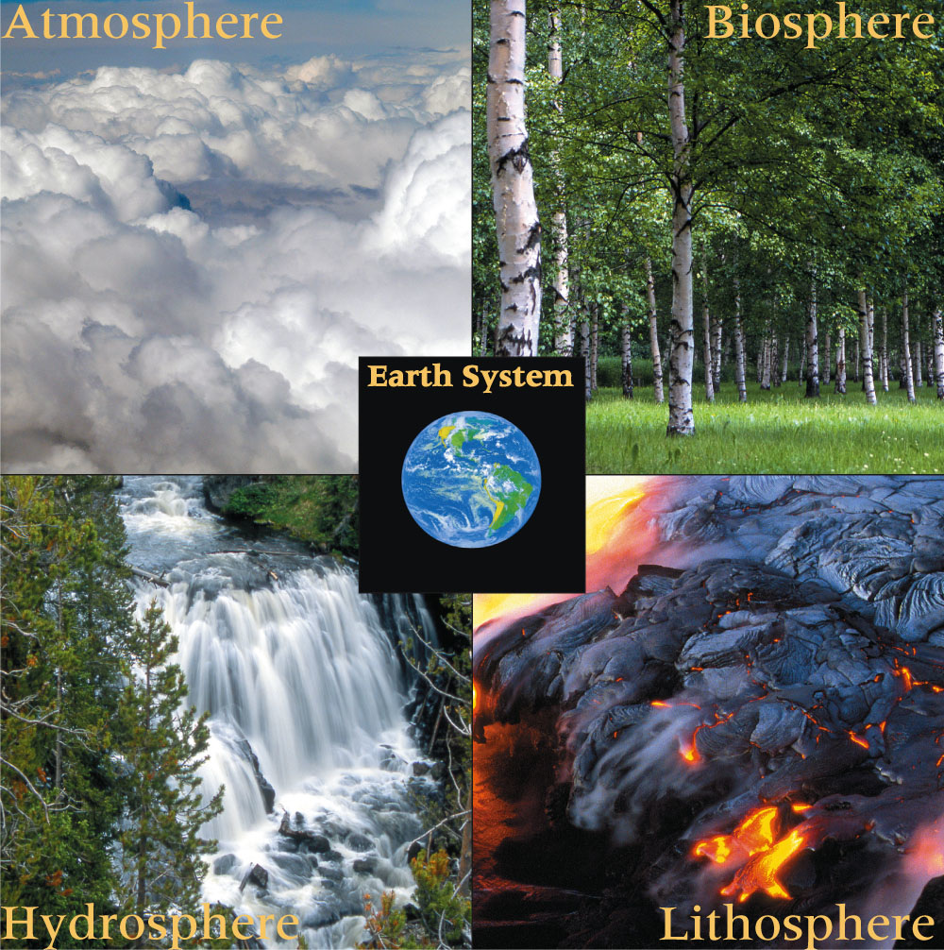
Living Earth Month Events 2023ce- This month is dedicated to the Sun/Moon times of Sark, Guernsey, Channel Islands. International Biological Diversity Day is on the 22nd.
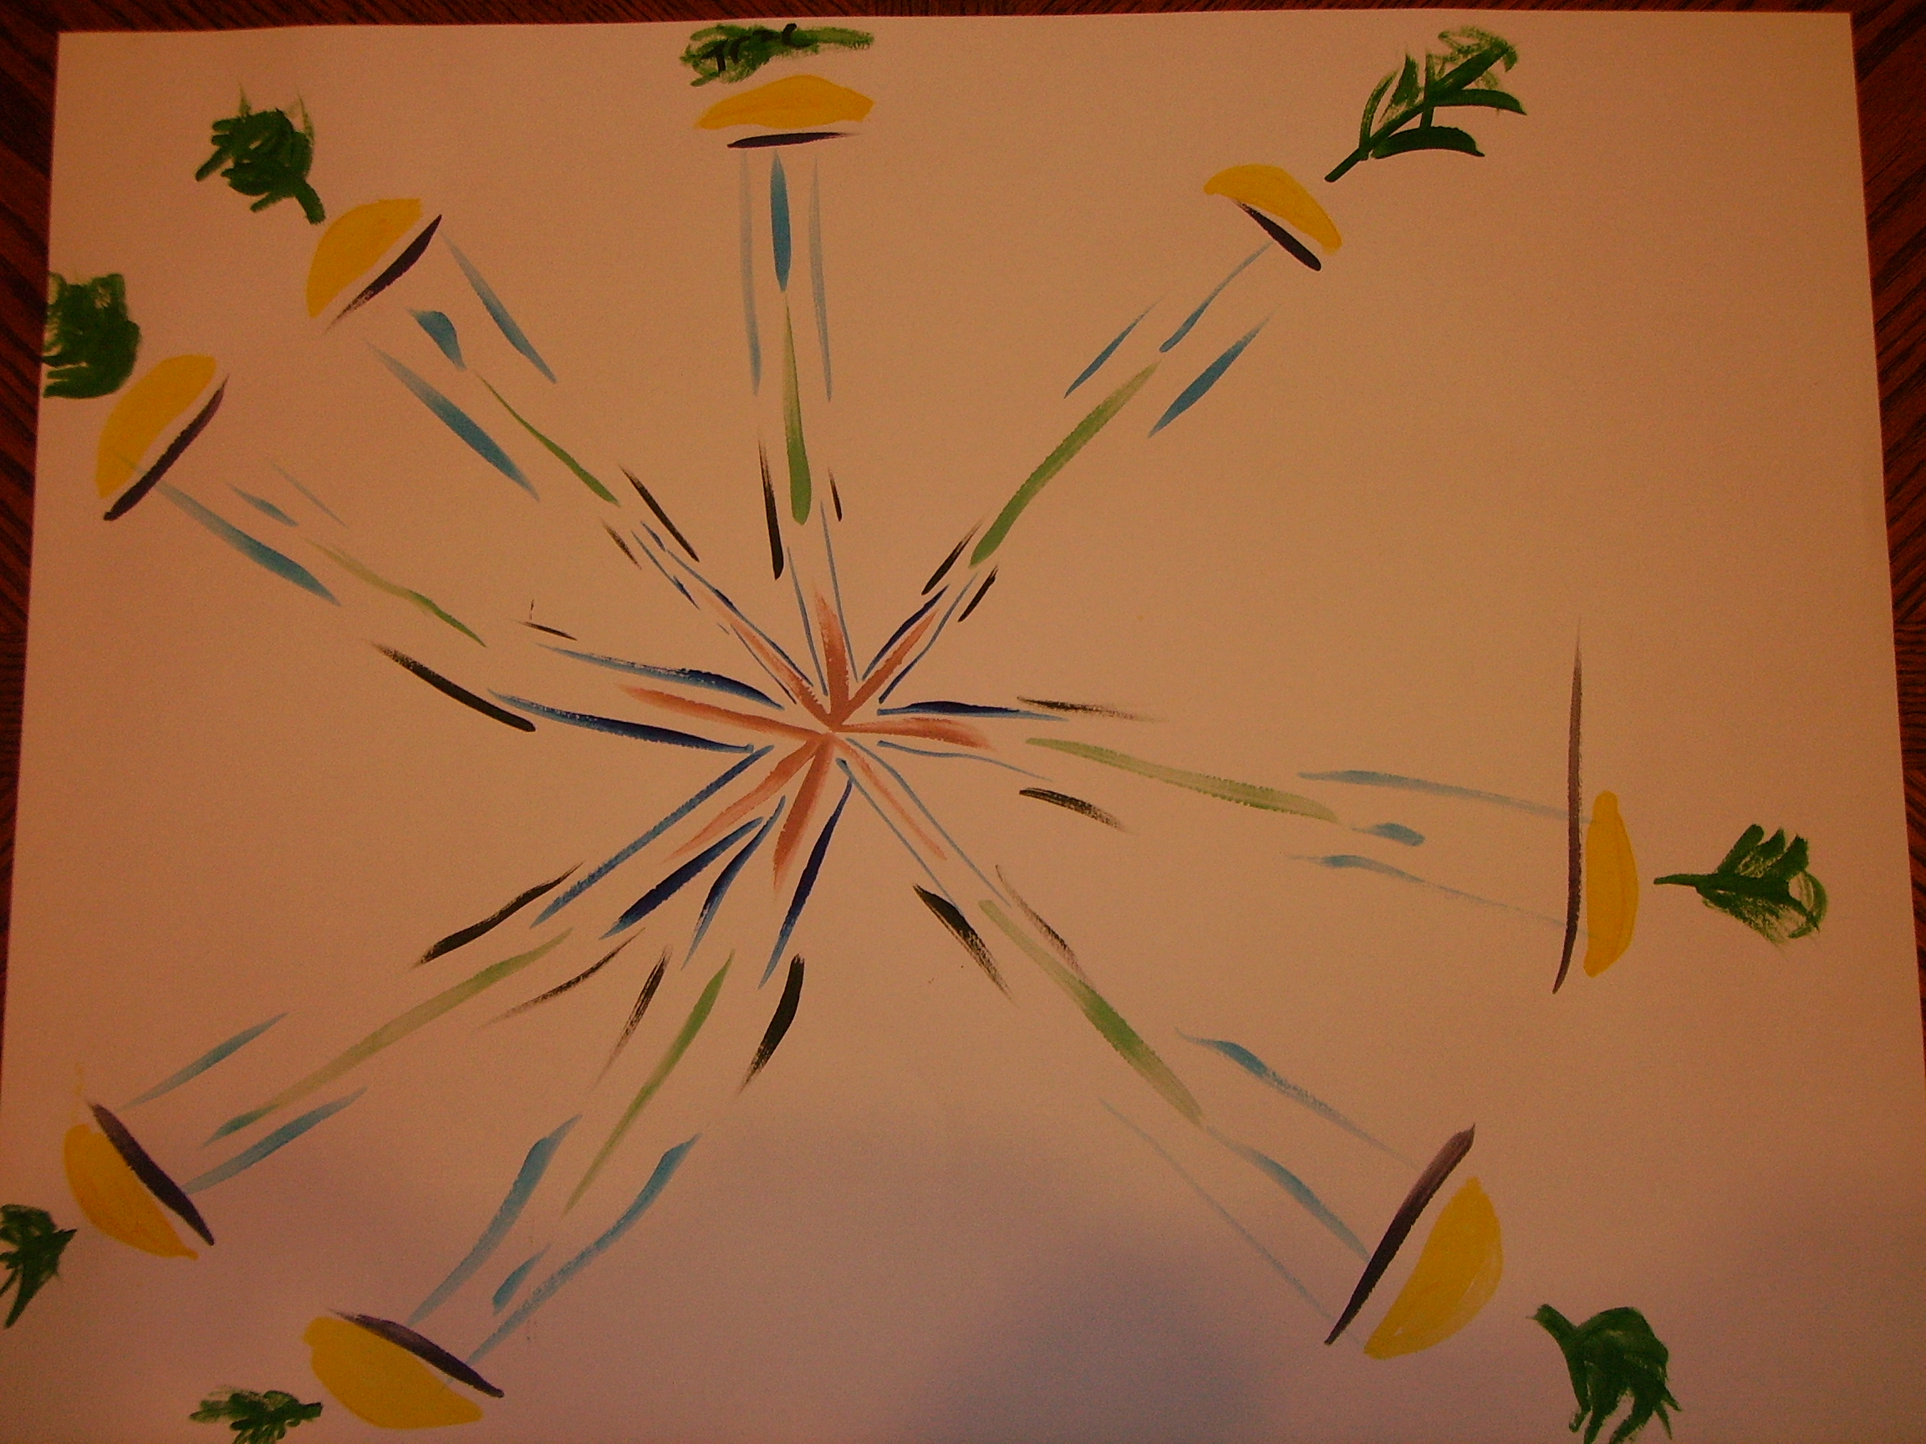
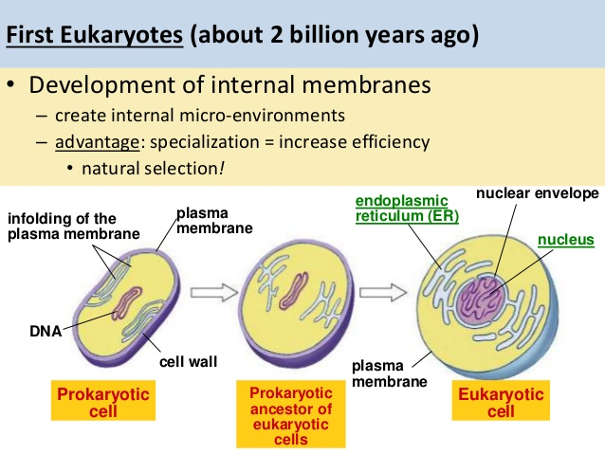
Left: Life became more complex around 2.0-2.5byp when the first cells, the Prokaryotes (4byp-2.5byp), began to share in common Cells, Cell Membranes and Ribosomes with the new Eukaryotes (2.0-2.5byp). Image Credit: slideshare
Right: The Living Planet Earth is the host of our Earth Community of Beings which include all minerals, seas, plants, and animals including humans. It also includes these four major spheres of our “garden planet of the Universe.” This calendar aims at showing how we humans are not separate from this beautiful Living Earth Community. Image Credit: Weebly
THE UNIVERSE STORY CALENDAR Living Earth/May-2023ce
TUSC>Sunday  TGC>Sunday | Moonday  Monday | Earthday  Tuesday | Humanityday  Wednesday | Universeday  Thursday | MilkyWayday  Friday | SolarSystemday  Saturday
Sun & Moon times are for Sark, Guernsey, Channel Islands | 1 | 2 World Tuna Day-UN Celebrating Berryan Date #2000! Days since the beginning of TUSCI on 11/9/17ce!  Earthday Weekly #287 | 3 World Press Freedom Day-UNUN  4 | 4 | 5  Moonset: 5:28am  Sunrise: 5:42am  Full Moon: 5:35pm  Sunset: 8:31pm  Moonrise: 8:39pm | 6
7 | 8 WWII Time of Remembrance and Reconciliation -UN | 9  Earthday Weekly #288 | 10 | 11 | 12  Moonrise: 2:55am  Sunrise: 5:31am  Moonset: 11:43am  Last Qtr: 2:29pm  Sunset: 8:41pm  Berryan Date #2010 | 13
14 World Migratory Bird Day-UNEP | 15 International Day of Families-UN | 16 International Day of Light-UNESCO  Earthday Weekly #289 | 17 International Day Against Biophobia ,Homophobia, and Transphobia-UN | 18 | 19  Moonrise: 5:01am  Sunrise: 5:21am  New Moon: 3:54pm  Sunset: 8:51pm  Moonset: 9:09pm | 20 World Bee Day-UN
21 | 22 International Biological Diversity Day-UN | 23  Earthday Weekly #290 | 24 | 25 | 26 | 27  Moonset: 2:23am  Sunrise: 5:12am  Moonrise: 12:13pm  First Qtr: 3:23pm  Sunset: 9:01pm
28 | 29 United Nations Peacekeepers Day-UN | 30  Earthday Weekly #291 | 31 World No Tobacco Day-WHO | KEY for Terms  TUSC=The Universe Story Calendar  TUS=The Universe Story  TGC=The Gregorian Calendar  ce=Common Era  bce=Before Common Era | KEY for Terms  by=Billion Years  my=Million Years  byp=Billion Years Past  myp=Million Years Past  AofT=As of Today  U!=Universe WHO= World Health Org. | Earth is 4.57byp and Living Cells were birthed  around 4.4byp

Eukaryote Cells/June month-2023ce
“Instead of failing, life mutated. A cyano-bacterium appeared...[Eukaryote Cells], that could deal with this oxygen, this powerful element that was tormenting all life. As was discussed in the story of the Supernovas, it was this very obstacle that made it possible for a creative advance to take place.” The Universe Story page 98 Eukaryotes chapter

Year of the Great Turning @round!- Our new story of the Universe has made possible for us humans to know that we to, like Eukaryote Cells on Earth 2.5byp “Instead of failing, life mutated.” Our Human Community of Beings are the alive ones to called to “mutate” our consciousness around issues like Climate Change. What an honor and joy to be the alive ones at this time in the human story!
OVERSHOOT- Eukaryotes, like humanity’s overshoot, are inconceivable, incremental, and evolved in gradualism unnoticed until their predicament unfolded to fruition. Solution #54 Walkable Cities
The Universe Story- Eukaryotes month covers the Proterozoic Eon of 2.5byp-541myp when a Eukaryote cell appeared that invented respiration in order to deal with the death element oxygen! The next 2by would see sexual reproduction and the first multi-cellular animals appear. Jellyfish and flatworms would come forth before the Cambrian Extinctions wiped out 80-90% of all species 541myp.
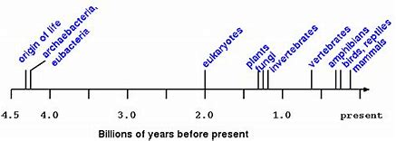
Eukaryotes Solstice and Season in 2023ce! Eukaryotes month celebrates our Earth-wide Eukaryotes Solstice that brings in Winter in the Southern and Summer in the Northern Hemisphere. The Eukaryotes Season takes us on a Universe Story journey from Cells to all Species, including when Humans emerged on Earth and eventually moved into Villages. Eukaryotes Season ends at Villages Equinox.
Above Right: The Eukaryote Cell was able to mutate the deadly element Oxygen into a breathable element so Life could continue. Image Credit: University of Manitoba
THE UNIVERSE STORY CALENDAR Eukaryotes/June-2023ce
TUSC>Sunday  TGC>Sunday | Moonday  Monday | Earthday  Tuesday | Humanityday  Wednesday | Universeday  Thursday | MilkyWayday  Friday | SolarSystemday  Saturday
Eukaryote  Cells appear from 2.5-2.0byp-541myp | Sun and Moon times are for Port-au-Prince, Haiti | KEY for Terms  TUSC=The Universe Story Calendar  TUS=The Universe Story  TGC=The Gregorian Calendar  ce=Common Era  bce=Before Common Era  UTC=Universal Time Coor |  | 1 Global Parents Day-UN | 2 | 3 World Bicycle Day-UN  Moonset: 5:30am  Sunrise: 6:12am  Moonrise: 7:12pm  Sunset: 7:23pm  Full Moon: 10:43pm
4 International Day of Innocent Children of Aggression-UN | 5 World Environment & Endangered Species Day-UN | 6  Earthday Weekly #292 | 7 World Food Safety Day-UN | 8 World Oceans Day-UN | 9 | 10  Moonrise: 12:48am  Sunrise: 6:12am  Moonset: 12:44pm  Last Qtr: 2:33pm  Sunset: 7:25pm
11  International Day Against Drug Abuse & Illicit Trafficking-UN | 12 World Day  Against Child Labor-UN | 13 International Albinism Awareness Day-UN  Earthday Weekly #293 | 14 World Blood Donor Day-WHO | 15 World Elder Abuse Awareness Day-UN | 16 International Day of Family Remittances-UN  Berryan Date #2045 | 17 World Day to Combat Desertification and Drought-UN  Moonrise: 5:32am  Sunrise: 6:13am  Moonset: 7:19pm  Sunset: 7:27pm  New Moon: 11:38pm
18 | 19 | 20 World Refugee Day-UN  Earthday Weekly #294 | 21Eukaryotes /June Solstice  World/Earth-Wide  14:58UTC-7:58am PST | 22  The Eukaryotes Season begins. It ends on Villages/Sept Equinox. | 23 Public Service Day-UN International Widow’s Day-UN | 24
25 | 26 International Day Against Drug Abuse & Illicit Trafficking-UN  Moonset: 12:49am  First Qtr: 2:51am  Sunrise: 6:15am  Moonrise: 1:11pm  Sunset: 7:29pm | 27 Micro, Small and Medium-sized Enterprises Day-UN  Earthday Weekly #295 | 28 | 29 International Day of the Tropics-UN | 30 International Asteroid Day-UN | KEY for Terms  by=Billion Years  my=Million Years  byp=Billion Years Past  myp=Million Years Past  AofT=As of Today  U!=Universe WHO=World Health Org  EST=Eastern Standard Time-USA UN=United Nations

Plants & Animals/July month-2023ce
“By the end of the Phanerozoic Eon, all five of the kingdoms of life were represented in Earth’s Community-Bacteria, Eukaryotes, Fungi, Plants and Animals…. There are an estimated 300,000 species of Plants, the 4th great kingdom…. The 5th kingdom is that of Animals, multicellular heterotrophs with developed capacities for digestion.”
The Universe Story pages 138-39 Plants & Animals chapter
Year of the Great Turning @round!- Botanists and biologists are discovering and naming new species all the time. Ironically, various plant and animal species are going extinct through the research in these same science fields. Individual scientists, like E. O. Wilson, have shown how each human alive today has a role to play in feeling and creating ways of coping with species extinctions.
OVERSHOOT 2023ce-The Earth Overshoot Day the last four years have been 7/29/2019ce; 8/22/2020ce; 7/29/2021ce; and 7/28/2022ce. This year’s at OvershootDay.org. #55 In-Home Recycling
The Universe Story- The Phanerozoic Eon from 541myp to 1950ce is full of storytelling that all ages of humans love: Dinosaurs, early Humans, first trees 370myp, extinctions, birth of the Atlantic Ocean, whales 25 myp, early cats & dogs 35myp. As we humans continue to companion and celebrate Plants & Animals a new understanding of their essential existence in the Earth Community will come forth!
Plants and Animals/Species Rule Now! Julius Caesar and his month July are history!
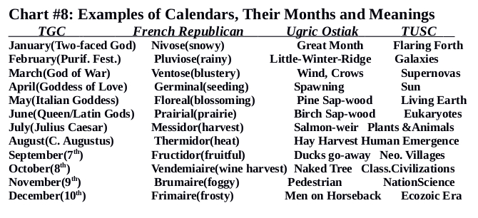
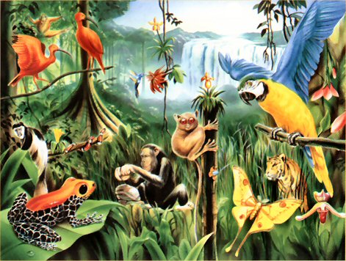
Right: Chart #8 from The Universe Story Calendar book, shows the deep new meaning TUSC brings forth.
Left: Plants & Animals month is a time of tremendous diversity and beauty. The conditions became right around 541myp for these new Earth Community Beings to come forth and flourish! This was the beginning of the Phanerozoic Eon of stupendous unfolding beauty. Image Credit: Weebly
THE UNIVERSE STORY CALENDAR Plants & Animals/July-2023ce
TUSC>Sunday  TGC>Sunday | Moonday  Monday | Earthday  Tuesday | Humanityday  Wednesday | Universeday  Thursday | MilkyWayday  Friday | SolarSystemday  Saturday
30 International Friendship Day-UN UN-World Day Against Trafficking in Persons | 31 | KEY for Terms  TUSC=The Universe Story Calendar  TUS=The Universe Story  TGC=The Gregorian Calendar  ce=Common Era  bce=Before Common Era | Plants &Animals month is from 541myp-7myp | Sun and Moon Times are for Mayabunder, Andaman/ Nicobar Islands, India | KEY for Terms  by=Billion Years  my=Million Years  byp=Billion Years Past  myp=Million Years Past  AofT=As of Today  U!=Universe  UN=United Nations | 1
2 | 3  Moonset: 4:23am  Sunrise: 4:56am  Full Moon: 5:10pm  Sunset: 5:49pm  Moonrise: 5:55pm | 4 International Day of Cooperatives-UN  Earthday Weekly #296 | 5 | 6 | 7  Berryan Date #2066 | 8
9 | 10  Sunrise: 4:58am  Last Qtr: 7:19am  Moonset: 11:28am  Sunset: 5:49pm  Moonrise: 11:37pm | 11 World Population Day-UN  Earthday Weekly #297 | 12 | 13 | 14 | 15 World Youth Skills Day-UN
16 | 17 | 18 Nelson Mandela International Day-UN  New Moon: 12:03am  Sunrise: 5:01am  Moonrise: 5:15am  Sunset: 5:49pm  Moonset: 6:29pm  Earthday Weekly #298 | 19 Islamic New Year sunset the 18th until sunset tonight. New Year below.  1st of Muharram  1445 AH Anno Hegirae | 20 | 21 | 22
23 | 24 | 25  Earthday Weekly #299 | 26  First Qtr: 3:38am  Sunrise: 5:03am  Moonrise: 11:35am  Sunset: 5:47pm  Moonset: 11:27pm  Mayan Calendar New Year | 27  THE 30th and 31ST ARE IN THE FIRST ROW ABOVE! | 28 World Hepatitis Day-WHO  Earth Overshoot Day-2022ce/2023ce’s Overshoot Day at OvershootDay.org | 29 Earth Overshoot Day-2021ce

Human Emergence/August month-2023ce
“The drama of self-consciousness [of the Human] takes place in five phases: the primordial Emergence of the Human; the Neolithic settlements [Villages]; the Classical Civilizations; the rise of Nations; and the Ecozoic Era.”
The Universe Story page 143 Human Emergence chapter
Year of the Great Turning @round!-Thomas Berry encouraged our human journey through his famous statement “The historical mission of our time is to reinvent the human - at the species level.” When each human being digs into the history of our species we see that our journey has been trying to live up to our Homo sapiens (wise human) naming by the botanist Carl Linnaeus in 1758ce.
Overshoot-With human emergence celebrated from up to seven million years past to neolithic villages appearing 10,000bce, human overshoot potential began when Homo habilis 2.6myp created and made tools which have only evolved over time. Drawdown.org Solution #56 Industrial Recycling
The Universe Story- This Human Emergence month brings Humanity Celebration Days from the 9th to the 19th. Partnering with the United Nations(UN), three particular days will be our focus. The 9th is International World Indigenous People’s Day, the 12th is International World Youth Day, and the 19th is World Humanitarian Day. Celebrate with your family, school, or other group. Go to UN.org/observances for info.
Chart #2 below shows how Humanityday in the Days of the Week in The Universe Story Calendar celebrates our Human Story and Community where The Gregorian Calendar did not. From TUSC book, pg.45
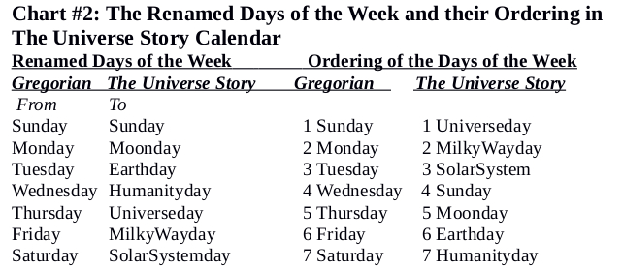
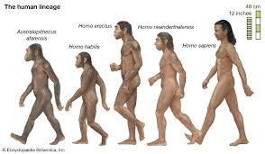
Left: Human Emergence month celebrates the present day continent of Africa where our ancestors first evolved from around seven million years past (myp) As of Today. In the picture, we see the evolution of the human lineage. Image Credit: brittanica.com
THE UNIVERSE STORY CALENDAR HumanEmergence/Aug-2023ce
TUSC>Sunday  TGC>Sunday |  |  | Moonday  Monday | Earthday  Tuesday | Humanityday  Wednesday | Universeday  Thursday | MilkyWayday  Friday | SolarSystemday  Saturday
Sun and Moon Times for Gilbert Islands, Republic of Kiribati |  |  | Human Emergence Period is from 7myp-10,000 bce | 1  Earthday Weekly #300 | 2  Sunrise: 8:29am  Full Moon: 8:33am  Moonset: 8:38am  Sunset: 8:40pm  Moonrise: 9:14pm | 3 | 4 | 5
6 Hiroshima 1945ce |  |  | 7 | 8 Humanity Celebration Days! Begin on the 9th to the 12th to the 19th of this Human Emergence month.  Earthday Weekly #301 | 9 International World Indigenous People’s Day-UN  (Celebration Day)  TUSCI  Nagasaki 1945ce | 10 on the 9th  Last Qtr: 12:30am  Moonrise: 2:15am  Sunrise: 8:29am  Moonset: 2:43pm  Sunset: 8:39pm | 11Berryan Date #2101 | 12 International World Youth Day-UN  (Celebration Day)
13 |  |  | 14 | 15 Humanity Celebration Days! From the 9th to the 12th to the 19th of Human Emergence month. TUSCI  Earthday Weekly #302 | 16  Moonrise: 8:10am  Sunrise: 8:28am  Moonset: 8:36pm  Sunset: 8:37pm  New Moon: 11:39pm | 17 | 18 | 19 World Humanitarian Day-UN (Celebration Day)
20 |  |  | 21 International Day Remembrance of Victims of Terrorism-UN | 22 International Day of Violence from Religion & Belief-UN  Earthday Weekly #303 | 23 International Day Remembrance of Slave Trade and its Abolition-UN | 24  Moonset: 1:24am  Sunrise: 8:26am  Moonrise: 1:54pm  Sunset: 8:35pm  First Qtr: 11:58pm | 25 | 26
27 |  |  | 28 | 29 International Day against Nuclear Tests-UN  Earthday Weekly #304 | 30 International Day of the Victims of Enforced Disappearances-UN | 31 International Day for People of African Descent-UN  Moonset: 8:16am  Sunrise: 8:24am  Full Moon: 3:37pm  Sunset: 8:33pm  Moonrise: 8:48pm | KEY for Terms  by=Billion Years  my=Million Years  byp=Billion Years Past  myp=Million Years Past  AofT=As of Today  U!=Universe  UN=United Nations | KEY for Terms  TUSC=The Universe Story Calendar  TUSCI-The Universe Story Calendar Initiative  TUS=The Universe Story  TGC=The Gregorian Calendar  ce=Common Era  bce=Before Common Era
 | CourCo | Calendar format courtesy of 2017Edwards Apps, Inc. www.sunrisesunset.com..

Neolithic Villages/September month-2023ce
“After 8000 BCE small settlements were growing beyond temporary encampments or cave dwellings into sustained forms of village life, consisting at first of a few hundred and later several thousand people…. If the first distinctive human relation with the planet Earth was the inauguration of tool-using processes, the second was the invention of horticulture and the domestication of animals within the context of the Neolithic Village.
The Universe Story pages 163-64 Neolithic Villages chapter
Year of the Great Turning @round!-With the arrival of neolithic villages came a new stage in the wisdom of Homo sapiens. Called the Great Disruption by some, this time showed how the last Homo species became more prolific inventors, creators, and makers of things and objects.
OVERSHOOT-Through domestication of plants and their seeds, animals including humans, and storage for later use, these former nomads transformed into the wise human creators of food, shelter, clothing, and a village! Drawdown Solution #57 Smart Thermostats-Home and Industrial
The Universe Story- With the Human Emergence beginning 7myp many transitions took place before the Neolithic Villages came around 8,000bce. Early cattle and modern horses came around 3.6myp while humans developed as hunters and gatherers of food. The archaic Homo sapiens arrived some 300,000 years ago.
Villages/Sept. Equinox unites our human family with our Sun and Earth this month. The Villages Season lasts three months until the Ecozoic/Dec. Solstice, formerly the Winter/Summer Solstice.
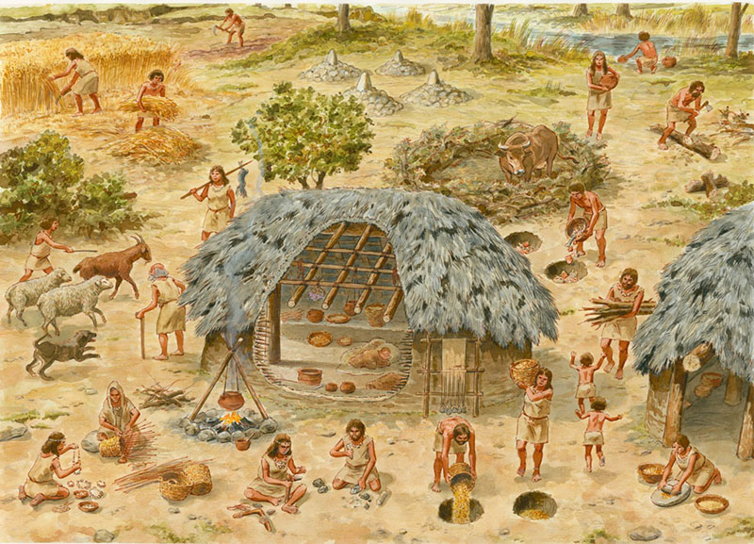
In Chart #14 from TUSCalendar book, we see what the New Year was for those who celebrate The Hebrew New Year on Rosh Hashanah and The Islamic New Year on Muharram.
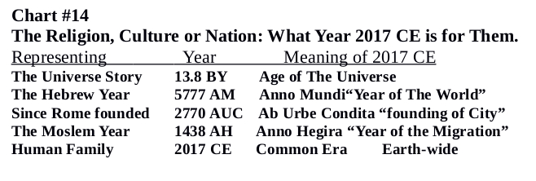
This Neolithic Village saved seeds each year and settled down. Image Credit: Shorthistory.org
THE UNIVERSE STORY CALENDAR Neolithic Villages/Sept-2023ce
TUSC>Sunday  TGC>Sunday | Moonday  Monday | Earthday  Tuesday | Humanityday  Wednesday | Universeday  Thursday | MilkyWayday  Friday | SolarSystemday  Saturday
Sun and Moon Times for Northern Marianna Islands, Saipan | Neolithic Villages are from 8,000bce to 3,500 bce | Key for Terms  by=Billon Years  my=Million Years  byp=Billion Years Past  myp=Million Years Past  AofT=As of Today  U!=Universe WHO= World Health Org. | KEY for Terms  TUSC=The Universe Story Calendar  TUSCI-The Universe Story Calendar Initiative  TUS=The Universe Story  TGC=The Gregorian Calendar  ce=Common Era  bce=Before Common Era |  | 1 JOIN TUSCI COMMUNITY AT TheUniverseStory Calendar.org | 2
3 | 4 | 5 International Day of Charity-UN  Earthday Weekly #305 | 6 | 7  Sunrise: 6:05am  Last Qtr: 8:22am  Moonset: 12:44pm  Sunset: 6:25pm  Moonrise: none | 8 International Literacy Day-UN  Berryan Date #2129 | 9
10 World Suicide Prevention Day-WHO | 11 | 12 International Day for South-South Cooperation-UN  Earthday Weekly #306 | 13 | 14 | 15 International Day of Democracy-UN  Moonrise: 6:01am  Sunrise: 6:05am  New Moon: 11:41am  Sunset: 6:19pm  Moonset: 6:33pm | 16 International Day-Preservation of the Ozone Layer-UN
17 | 18 | 19  Earthday Weekly #307 | 20 | 21 International Day of Peace-UN | 22 Villages/Sept Equinox/Season  World/Earth-wide  11:50pm PST  06:50 UTC on the 23rd | 23  First Qtr: 5:33am  Sunrise: 6:06am  Moonrise: 1:03pm  Sunset: 6:13pm  Moonset: none
24 World Rivers Day  The Villages/Sept Equinox Season begins. It ends on Ecozoic Solstice. | 25 Rosh Hashana-Judaism New Year-5783 A.M.(Anno Mundi) sunset 25th until nightfall on the 27th | 26 International Day for Elimination of All Nuclear Weapons-UN  Earthday Weekly #308 | 27 | 28 | 29 UN-International Day of Food Loss/Waste Reduction Awareness  Moonset: 5:36am  Sunrise: 6:06am  Moonrise: 6:06pm  Sunset: 6:08pm  Full Moon: 7:59pm | 30 UN-World Maritime Day

Classical Civilizations/October month-2023ce
“Meanwhile the primary technological inventions were pushing on to ever-greater power and productivity. The natural world as a resource for human use was being discovered. This period at the close of the fourth and throughout the first half of the third millennium bce [4,000-3,500] was a decisive period in the advance of the human in its basic technologies.” The Universe Story page 184 Classical Civilizations chapter
Year of the Great Turning @round!- 88 civilizations collapsed into ruin from 3,000bce to 1,000ce. Another 100 have come and gone through collapse since 1,000ce. Our present cultures and nations can be considered as one, interdependent, global, planetary human civilization. Because of our human caused global overshoot of using up Earth’s non-renewable natural resources, humanity as a whole species is headed for a collapse of our planetary society as of today.
OVERSHOOT-”The more potent human technology became, the more man turned into a colossus. Each human colossus required more resources and more space than each pre-colossus.” pg. 155 Overshoot. William Catton, Jr. 1980ce. Drawdown.org Solution #58 Landfill Methane capture
The Universe Story- The Classical Civilizations entered the Human Story around 3500bce with the increase in population and the need of various resources which cities provided. Chronic warfare, the major religions along with nation building was happening all the way up to the 1500’s of our Common Era (ce). With the world population between 400-500 million people, the close of the Classical Civilizations period saw a deadly outbreak of the Black Death in Europe beginning in 1340ce that killed around 30 million people.
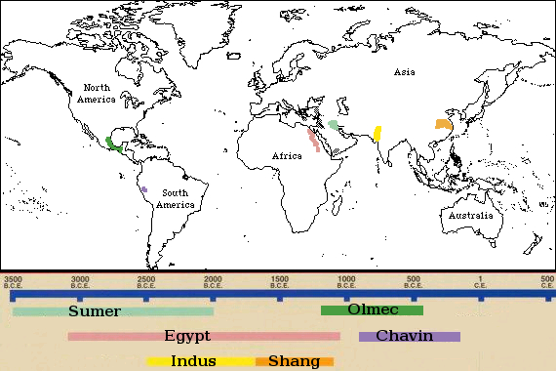
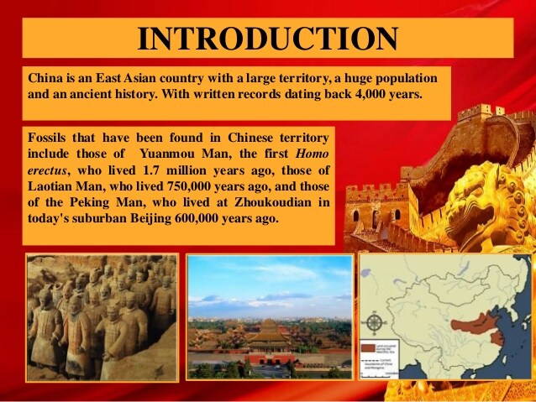
Right: Classical Civilizations from 3500bce to 500ce. Image Credit: the24hourtala-Wordpress.com
Left: Classical Chinese Civilizations are one example of how humanity has evolved to today. Image Credit: Slideshare
THE UNIVERSE STORY CALENDAR Classic. Civilizations/Oct-2023ce
TUSC>Sunday  TGC>Sunday | Moonday  Monday | Earthday  Tuesday | Humanityday  Wednesday | Universeday  Thursday | MilkyWayday  Friday | SolarSystemday  Saturday
1 International Older Persons Day-UN | 2 International Day of Non-Violence-UN | 3 World Habitat Day-  UN  Earthday Weekly #309 | 4 | 5 World Teacher’s Day-UN | 6 Berryan Date #2157 | 7 Moonrise: 1:29am  Last Qtr: 5:49am  Sunrise: 6:16am  Moonset: 11:56am  Sunset: 6:42pm ON THE 6TH
8 | 9 World Post Day-UN | 10 World Mental Health Day-UN  Earthday Weekly #310 | 11 International Day of the Girl Child-UN | 12 | 13 International Day of Disaster Risk Reduction-UN | 14 Sunrise: 6:08am  Moonrise: 6:08am  New Moon: 9:56am  Sunset: 6:45pm  Moonset: 7:01pm
15 International Day of Rural Women-UN | 16 World Food Day-UN | 17 International Day Eradication of  Poverty-UN  Earthday Weekly #311 | 18 | 19 | 20 | 21 Moonset: 12:58am  Sunrise: 6:01am  Moonrise: 11:35am  Sunset: 6:49pm  First Qtr: 7:31pm
22 | 23 | 24 United Nations Day-UN  Disarmament Week-UN  Earthday Weekly #312 | 25 | 26 | 27 World Day for Audio Visual Heritage-UN | 28 Moonset: 5:45am  Sunrise: 5:56am  Full Moon: 12:25pm  Sunset: 6:53pm  Moonrise: 7:08pm
29 | 30 Disarmament Week Ends-UN | 31 Samhain/  Wiccan New Year  World Cities Day-UN  Earthday Weekly #313 | Sun and Moon Times for Pitcairn Islands, Adamstown | KEY for Terms  by=Billion Years  my=Million Years  byp=Billion Years Past  myp=Million Years Past  AofT=As of Today  U!=Universe  UN=United Nations | KEY for Terms  TUSC=The Universe Story Calendar  TUS=The Universe Story  TGC=The Gregorian Calendar  ce=Common Era  bce=Before Common Era | Classical Civilizations month is from 3500bce to 1543ce

NationScience/November month-2023ce
“Membership in the nation community easily becomes more significant than membership in a religious or cultural tradition. The nation-state has indeed become the sacred community.” The Universe Story page 213 Rise of Nations
“New technologies were emerging, new instruments of navigation, new ways of plotting the seas and continents, new instruments of warfare, new energy sources, new methods of production and commercial distribution.”
The Universe Story page 225 The Modern Revelation chapter
Year of the Great Turning @round- “New technologies…” of all kinds have been emerging these past 500 years with no real resource limits set. Each human being alive today needs to know this fact.
OVERSHOOT-The last three chapters of Catton’s book Overshoot are “Backing into the Future”, “Turning Around”, and “Facing the Future Wisely.” Who is? Drawdown Solution #59 Bike Infrastructure
The Universe Story- This month sees two chapters coming together from TUS book that have the same time periods, 1543-1950ce, beginning with Copernicus’ De Revolutionibus book that told the fact that the Earth revolves around the Sun, not the other way around. Nations had the other kind of “Revolution” going on as the numbers of countries grew to 193 (in the United Nations) by 2023ce.
Chart #13 below shows the paradigm shift that is happening at this time in our journey as a Human Species, at this time of Great Promise and Great Peril, when our new World Calendar comes forth!

Above: Galileo Galilei and his inventions during our NationScience time period of 1543-1950ce. He is seen as one of our greatest scientists. He led the way to our nations of today astronomy, technology, and scientific facts and methods over religious beliefs. His discovery of Jupiter’s four moons with his nine inch telescope paved the way for confirmation of Nicholas Copernicus’ theory of a helio/sun-centered Universe at that time. Image Credit: Owlcation (Galileo and planets); Slideshare (Inventions)
THE UNIVERSE STORY CALENDAR-NationScience/Nov.-2023ce
TUSC>Sunday  TGC>Sunday | Moonday  Monday | Earthday  Tuesday | Humanityday  Wednesday | Universeday  Thursday | MilkyWayday  Friday | SolarSystemday  Saturday
NationScience Month covers 1543-1950ce | Sun and Moon Times for Kirkwall, Orkney Isles, Scotland | www.TheUniverseStoryCalendar.org | 1 | 2 International Day to End Impunity for Crimes against Journalists-UN | 3 | 4 Sunrise: 7:38am  Last Qtr: 8:38am  Moonset: 3:09pm  Sunset: 4:13pm  Moonrise: 10:24pm O
5 UN-Inter. Week of Science & Peace-Day 1  World Tsunami Awareness Day-UN | 6 International Day for Preventing the Exploitation of Envir. In War/Armed-UN | 7  Earthday Weekly #314 | 8 Last day of The Roman Gregorian Calendar of 1582-2017ce on 11/8/2017ce | 9 2nd Universe Day International!-TUSCI  6th Anniversary of The Universe Story Calendar 2017-23CE  31th Anniversary of The Universe Story! | 10 World Science Day for Peace and Development-UN  Berryan Date #2192  Thomas Berry’s 109th  Anniversary of Birth  (on the 9th) | 11 UN-Inter. Week of Science & Peace-Day 7  **FLARING FORTH** CELEBRATION!  31^{H} Anniversary of The Universe Story!!  Time and Place TBA
12 | 13 Sunrise: 7:57am  Moonrise: 8:21am  New Moon: 9:29am  Moonset: 3:24pm  Sunset: 3:55pm | 14 World Diabetes Day-UN  Earthday Weekly #315 | 15 | 16 International Day of Tolerance-UN  World Philosophy Day-UN | 17 | 18
19 International Restorative Justice Week 19^{th--}25^{th-} | 20 World Day of Remembrance Road Traffic Victims-UN  Sunrise: 8:14am  First Qtr: 10:51am  Moonrise: 2:20pm  Sunset: 3:41pm  Moonset: 11:13pm | 21 World Television Day-UN  Earthday Weekly #316 | 22 | 23 | 24 | 25 International Day for Elimination of Violence against Women-UN
26 Liturgical New Year: Western Christians | 27 Sunrise: 8:29am  Moonset: 9:11am  Full Moon: 9:17am  Moonrise: 2:45pm  Sunset: 3:29pm | 28  Earthday Weekly #317 | 29 International Day of Solidarity with the Palestinian People-UN | 30 All Victims of Chemical Warfare-UN | KEY for Terms  TUSC=The Universe Story Calendar  TUS=The Universe Story  TGC=The Gregorian Calendar  ce=Common Era  bce=Before Common Era | KEY for Terms  by=Billion Years  my=Million Years  byp=Billion Years Past  myp=Million Years Past  AofT=As of Today  U!=Universe

The Ecozoic Era/December month-2023ce
“We few billion humans alive today represent through no democratic choice whatsoever the millions of generations of our ancestors and millions more generations of our potential descendants, with all their hopes and dreams and creations. We randomly-alive-today people actually have the power to end this evolutionary miracle...”
The New Universe and the Human Future (Abrams-Primack) page 100
Year of the Great Turning @round!- This final month of the sixth full year of The Universe Story Calendar brings reality to The Ecozoic Era (TEE). Unlike the old December this new month wakes us to this fact: “We randomly-alive-today people actually have the power to end this evolutionary miracle...”
OVERSHOOT-This Ecozoic Era calls each individual human being to begin “Facing the Future Wisely.” Through deep acceptance and pro-generative resolutions to our ecological choices over our past 300 years of industrialism, we can wisely begin to adapt. Drawdown Solution #60 Composting
The Universe Story- This month brings forth our new Eon beginning in 1950ce; The Universe Story Eon (TUSE). TUSE gives us our comprehensive context going forward to understand and celebrate. In addition, The Anthropocene Period (TAP), is welcomed as our Human species becomes consciously self-aware.
Ecozoic Solstice is celebrated World-wide this month. The Ecozoic Season lasts until Supernovas Equinox.
Table 2: Analysis of Several Modes of Adaptation to Ecologically Inexorable [Impossible to stop] Change
NEW ECOLOGICAL UNDERSTANDINGS in “Overshoot” by William Catton, Jr. pg 71.
Adaptations (by some) Circumstance: Consequence: Names
Major Institutional = Circumstance: Age of + Consequence: Change to forms that = Realism change essential Exuberance is Over accord with finite limits
Faith in Technology & = Circumstance accepted + Consequence disregarded = Cargoism Progress to save us
Family planning, recycling, = Circumstance disregarded + Consequence partially accepted = Cosmeticism anti-pollution will save us
No History significance = Circumstance disregarded + Consequence disregarded = Cynicism Limitlessness Valid = Circumstance denied + Consequence denied = Ostrichism
ABOVE: The essential move from “Limitlessness of resources/Ostrichism” to “Deep adaptation to Human Overshoot/Realism.” Where/who are you?
THE UNIVERSE STORY CALENDAR Ecozoic Era/December-2023ce
TUSC>Sunday  TGC>Sunday | Moonday  Monday | Earthday  Tuesday | Humanityday  Wednesday | Universeday  Thursday | MilkyWayday  Friday | SolarSystemday  Saturday
31 New Year’s Eve-The Universe Story Calendar | KEY for Terms  by=Billion Years  my=Million Years  byp=Billion Years Past  myp=Million Years Past  AofT=As of Today  U!=Universe  UTC=Universal Time Coordination-UK | KEY for Terms  TUSC=The Universe Story Calendar  TUS=The Universe Story  TGC=The Gregorian Calendar  ce=Common Era  bce=Before Common Era  EST=Eastern Standard Time-USA | Sun and Moon Times for Turks & Caicos Islands, Cockburn Town |  | 1 World AIDS Day-UN | 2 International Day for the Abolition of Slavery-UN
3 International Day of Persons with Disabilities-UN | 4 | 5 World Soil Day-UN International Volunteer Day-UN  Earthday Weekly #318 | 6 Last Qtr: 12:50am  Sunrise: 6:08am  Moonset: 12:22pm  Sunset: 5:02pm  Moonrise: none ON THE 5TH | 7 | 8 | 9 International Anti-Corruption Day-UN
10 Human Rights Day-UN | 11 International Mountain Day-UN | 12 International Universal Health Coverage Day-UN  Earthday Weekly #319 | 13 Moonrise: 5:53am  Sunrise: 6:12am  Moonset: 4:46pm  Sunset: 5:03pm  New Moon: 6:33pm ON 12TH | 14 | 15  Berryan Date #2227 | 16
17 | 18 International Migrants Day-UN | 19 Sunrise: 6:16am  Moonrise: 11:50am  First Qtr: 1:40pm  Sunset: 5:06pm  Moonset: none  Earthday Weekly #320 | 20 International Human Solidarity Day-UN | 21 Ecozoic/Dec  Solstice & Season  World/Earth-wide 7:27pm PST  03:27 UTC on the 22nd  Yule/New Year-Witta | 22  The Ecozoic Season begins. It ends on Supernovas/March Equinox. | 23
24 | 25 | 26 Moonset: 6:04am  Sunrise: 6:20am  Moonrise: 4:53pm  Sunset: 5:10pm  Full Moon: 7:34pm  Earthday Weekly #321 | 27 International Day of Epidemic Prep.-UN | 28 2024ce:  Year of Facing the Future Wisely!  TUSCI | 29 | 30 The 31st, New Year’s Eve, of 2024ce is above in the first row.

THE UNIVERSE STORY CALENDAR-Flaring Forth/January-2024ce
TUSC>Sunday  TGC>Sunday |  |  | Moonday  Monday | Earthday  Tuesday | Humanityday  Wednesday | Universeday  Thursday | MilkyWayday  Friday | SolarSystemday  Saturday
 |  |  | 1. New Year’s  Day!  The Universe Story Calendar! | 2  Earthday Weekly #322 | 3 2024ce:  Year of Facing the Future Wisely!  TUSCI | 4 | 5 Berryan Date #2248 | 6
7 |  |  | 8 | 9  Earthday Weekly #323 | 10 | 11 | 12 | 13  Orthodox Christianity New Year
14 |  |  | 15 | 16  Earthday Weekly #324 | 17 | 18 | 19 | 20
21 |  |  | 22 | 23  Earthday Weekly #325 | 24 International Day of Education-  UNESCO | 25 | 26 | 27
28 |  |  | 29 | 30  Earthday Weekly #326 | 31 | Many faiths, nations, cultures and calendars celebrate Flaring Forth 1, 2024ce as New Year’s Day. | Another Circle Around the Sun!  2024ce
 |  | Calendar format courtesy of 2017 Edwards Apps, Inc. www.SunriseSunset.com.
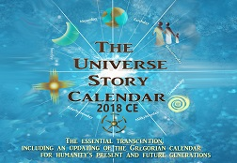
Below are the publications of The Universe Story Calendar Initiative (TUSCI) since it’s promulgated beginning at the 25th Anniversary Flaring Forth Celebration of The Universe Story book of 1992ce on NationScience/Nov. 9, 2017ce. They are: The Universe Story Calendar Book, the five Universe Story Calendar’s from 2018-2022ce including this one! In the middle of the top row is the epic book The Universe Story. Image Credit: Ebay.com

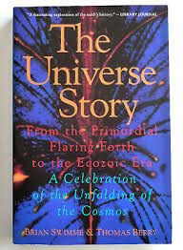
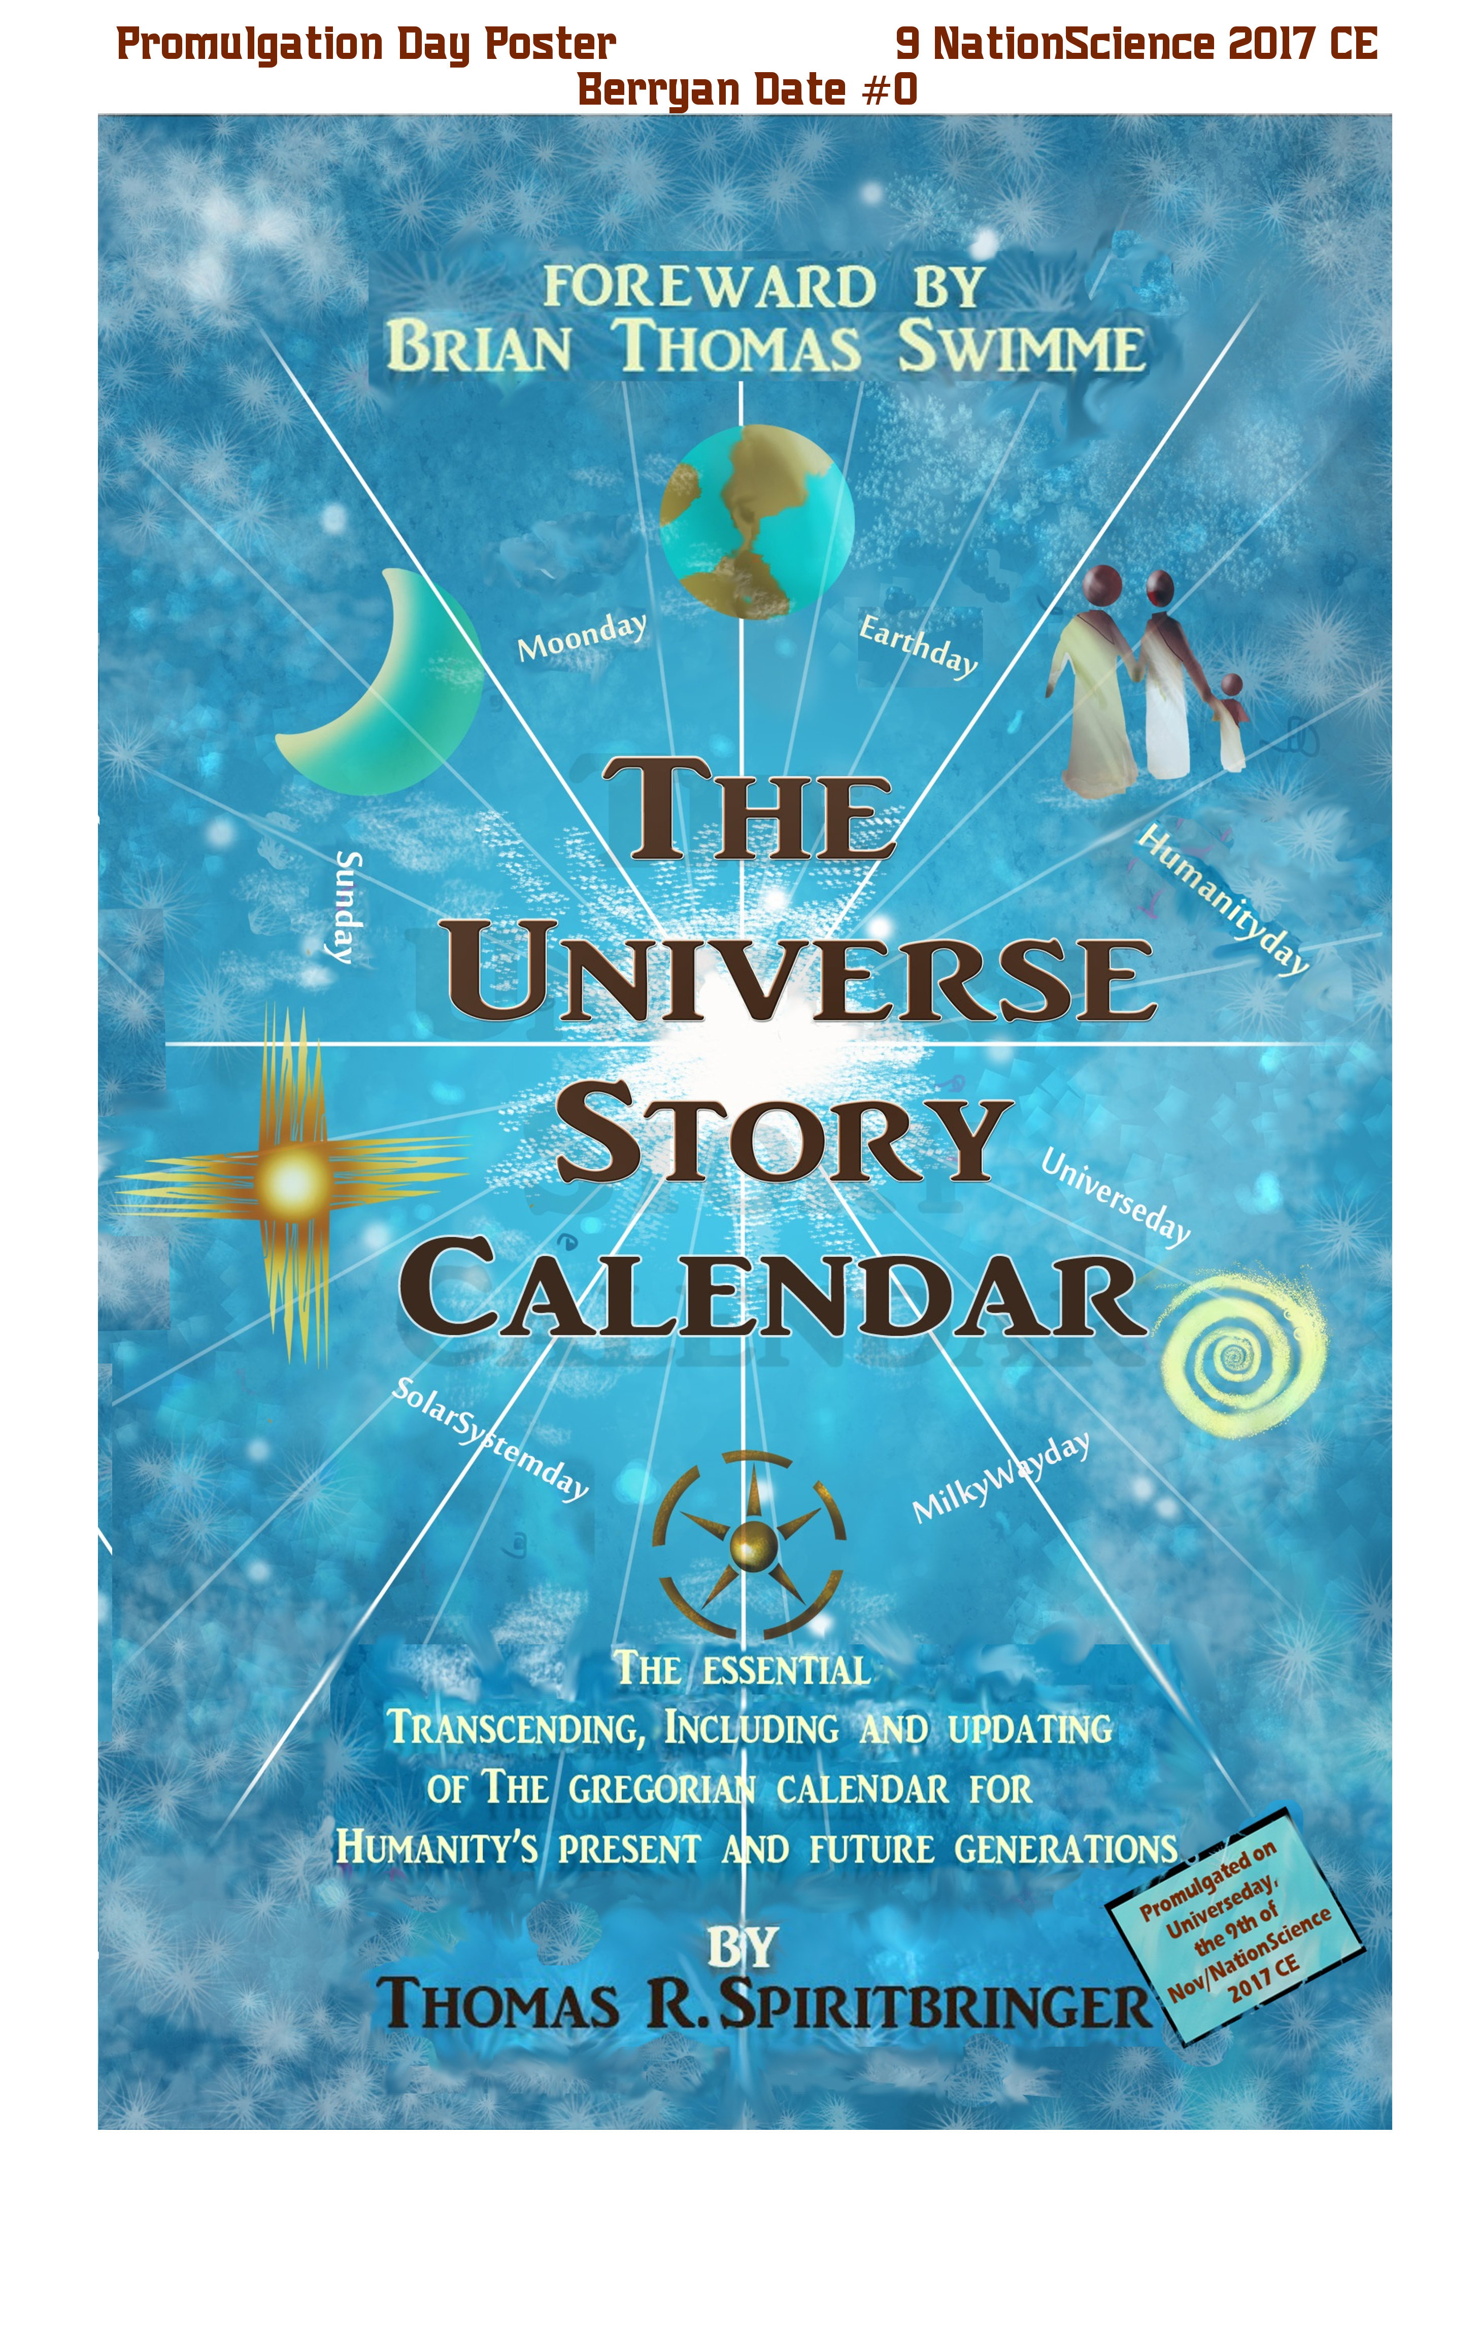

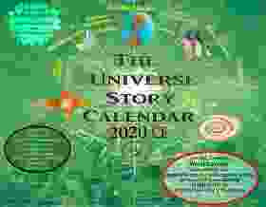
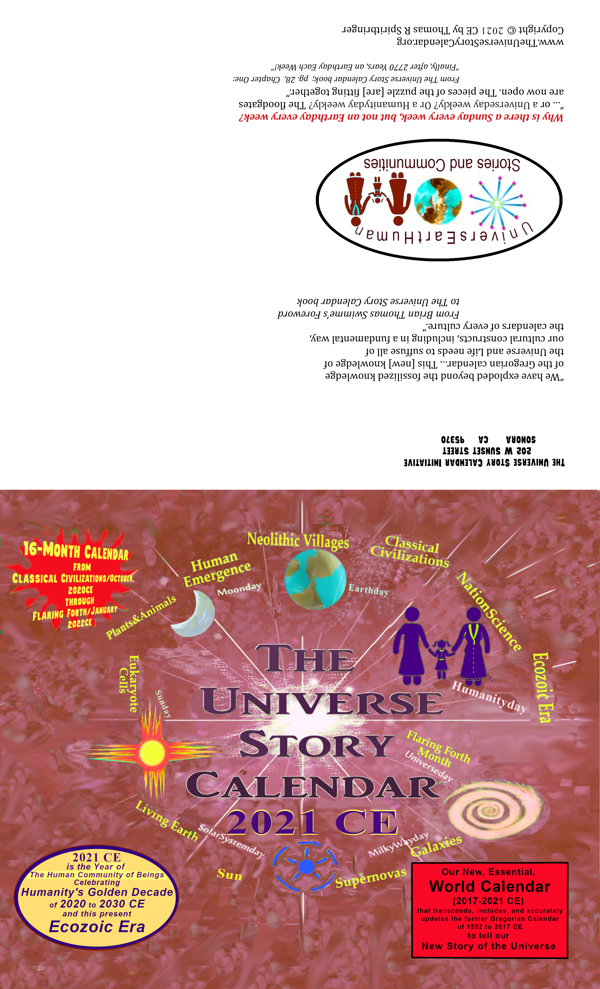
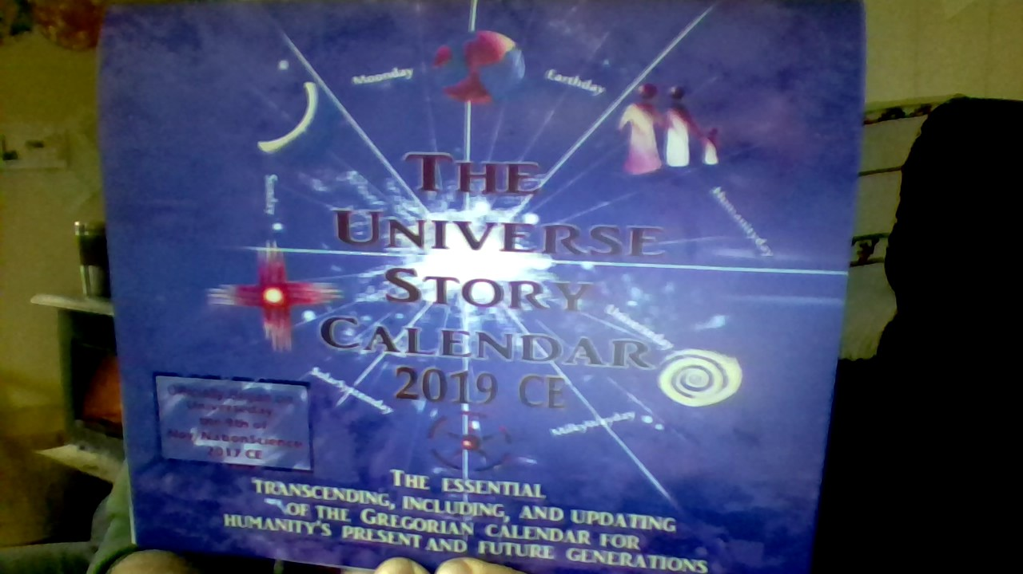

NOTES

